**BILLYRACXX WEBSITE OUTLINE**

**(www.billyracxx.com)**

**MAIN REFERENCE:** [**https://www.travisscott.com/**](https://www.travisscott.com/)

[**TRAVIS SCOTT**](https://www.travisscott.com/)

**TABS**

* **TOUR (LEFT CORNER)**
* **SHOP (RIGHT CORNER)**
* **MUSIC (BOTTOM CENTER)**

**MAIN PAGE**

* **CURRENT AVAILABLE MERCH COLLECTION (hold off for now)**
* [**A COUNTDOWN TO NEXT SINGLE**](https://drive.google.com/drive/folders/1TtiL9GfCg8uiswcBX_n0nC3EZfMktuzQ?usp=drive_link) **(BLURRED COVER ART W/ COUNTDOWN OVER IT) (COUNTDOWN:SEPTEMBER 12TH)**
* [**A COUNTDOWN TO NEXT MERCH RELEASE**](https://drive.google.com/file/d/1G0gclD8uGZzDsswfk7sEqovwBd5Xzpax/view?usp=drive_link)

[**(BLURRED PIC OF COLLECTION W/ COUNTDOWN OVER IT)**](https://drive.google.com/file/d/1G0gclD8uGZzDsswfk7sEqovwBd5Xzpax/view?usp=drive_link)

* [**MOST RECENT SINGLE RELEASE**](https://drive.google.com/drive/folders/1NTBSMmVOqNrQcbC0sroUOE6kGzHbwWuo?usp=drive_link) **(WHEN CLICKED, IT TAKES YOU TO PAGE WITH EMBEDDED** [**YOUTUBE MUSIC VIDEO**](https://youtu.be/1OAhptdsst0?feature=shared) **OR**

[**COVER ART**](https://drive.google.com/drive/folders/1NTBSMmVOqNrQcbC0sroUOE6kGzHbwWuo?usp=drive_link) **AND EMBEDDED LINKS TO** [**SPOTIFY**](https://open.spotify.com/album/4o1qq5fu0q2MNvKLVK1rfN)**,** [**APPLE MUSIC**](https://music.apple.com/us/album/aliens-cry-single/1782916407)**)**

**EXAMPLE:** [**https://www.travisscott.com/**](https://www.travisscott.com/)

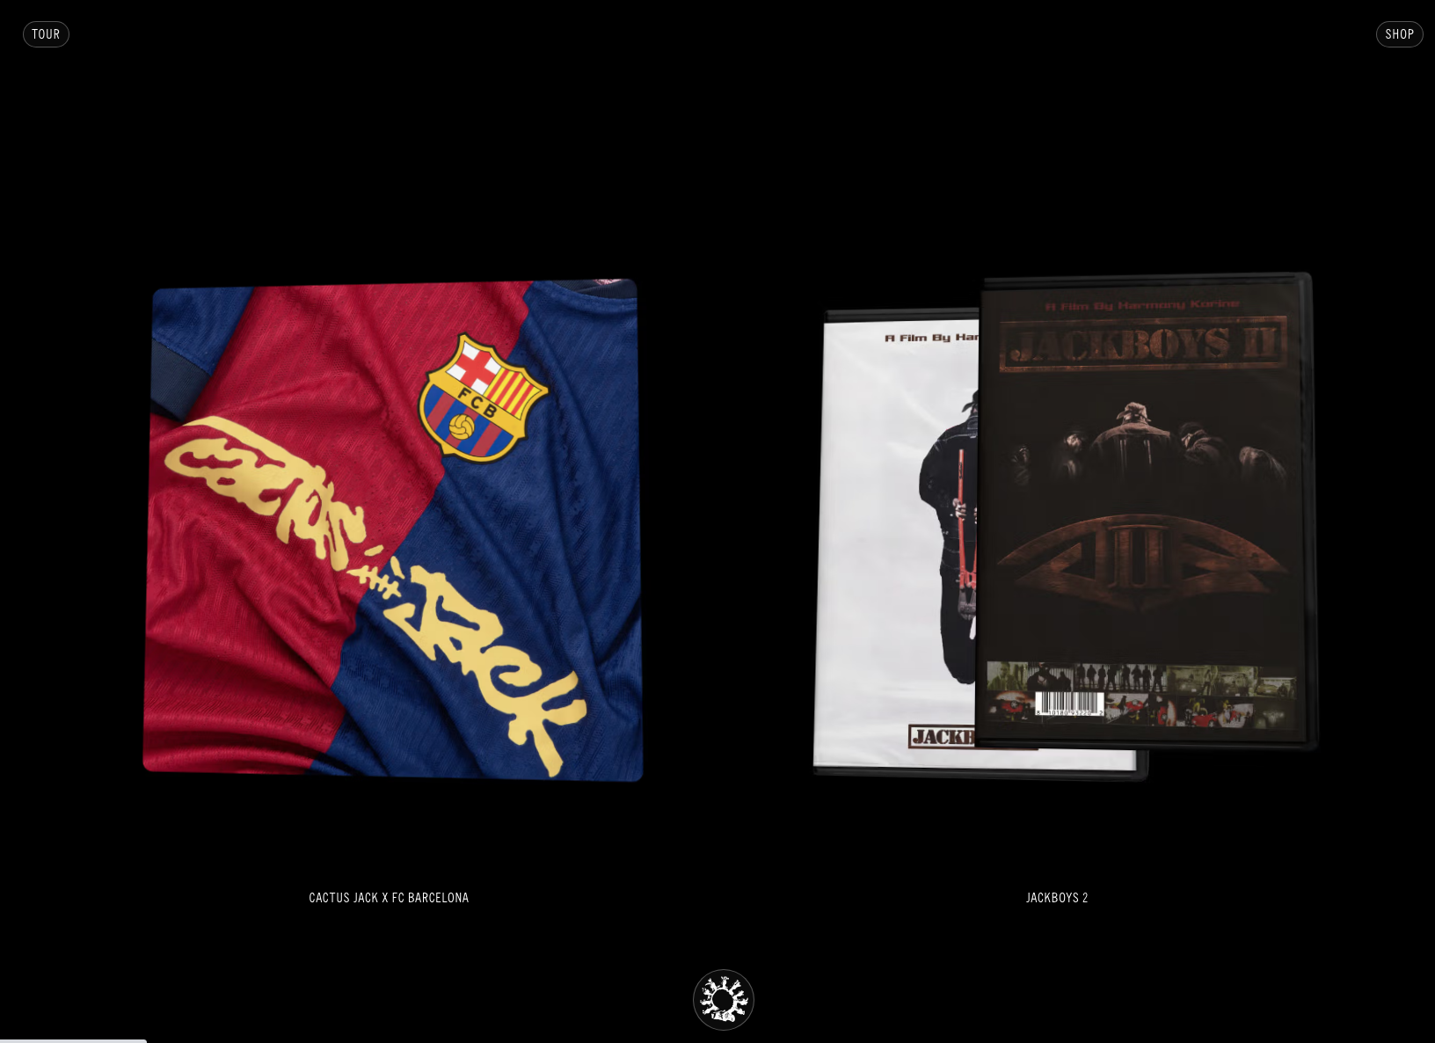

**TOUR TAB**

* **1 PAGER W/ TOUR GRAPHIC & DATES (ADD LARGE “TOUR TBA” PNG TEXT TO CENTER OF GRAPHIC)** [**(USE THIS PHOTO AS GRAPHIC & BLURR IT OUT)**](https://drive.google.com/file/d/1EsdbRjD_sa9cODmcdgt-L_CrBwarumAF/view?usp=drive_link)

**EXAMPLE:** [**https://www.travisscott.com/tour/**](https://www.travisscott.com/tour/)

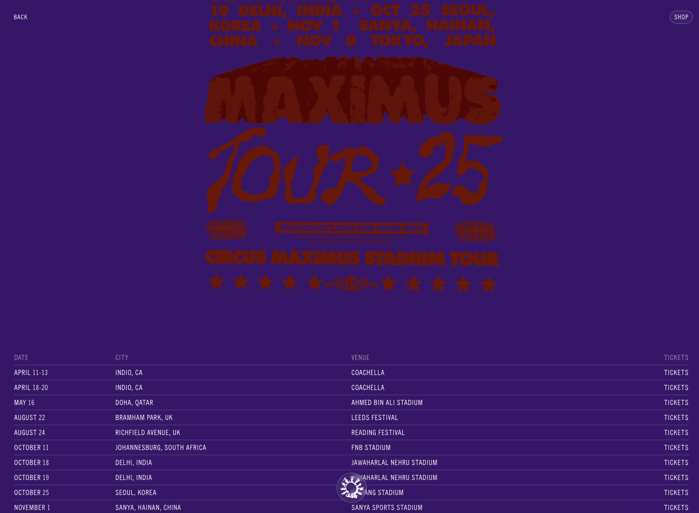

**SHOP TAB**

* **MADDOG CAPSULE**

[**USE THIS PIC AS COVER**](https://drive.google.com/file/d/1G0gclD8uGZzDsswfk7sEqovwBd5Xzpax/view?usp=drive_link)

**WHEN COVER IS CLICKED IT SHOULD LEAD TO A BLURRED PRODUCT PAGE THAT SAYS TBA**

* **AIMC CAPSULE**

[**USE THIS PIC AS COVER**](https://drive.google.com/file/d/1Yv-RZ9AH-qdfcXtLOzERn3Aaeho4PfWo/view?usp=drive_link)

**WHEN COVER IS CLICKED IT SHOULD LEAD TO A BLURRED PRODUCT PAGE THAT SAYS TBA**

**EXAMPLE:**[**https://shop.travisscott.com/**](https://shop.travisscott.com/)

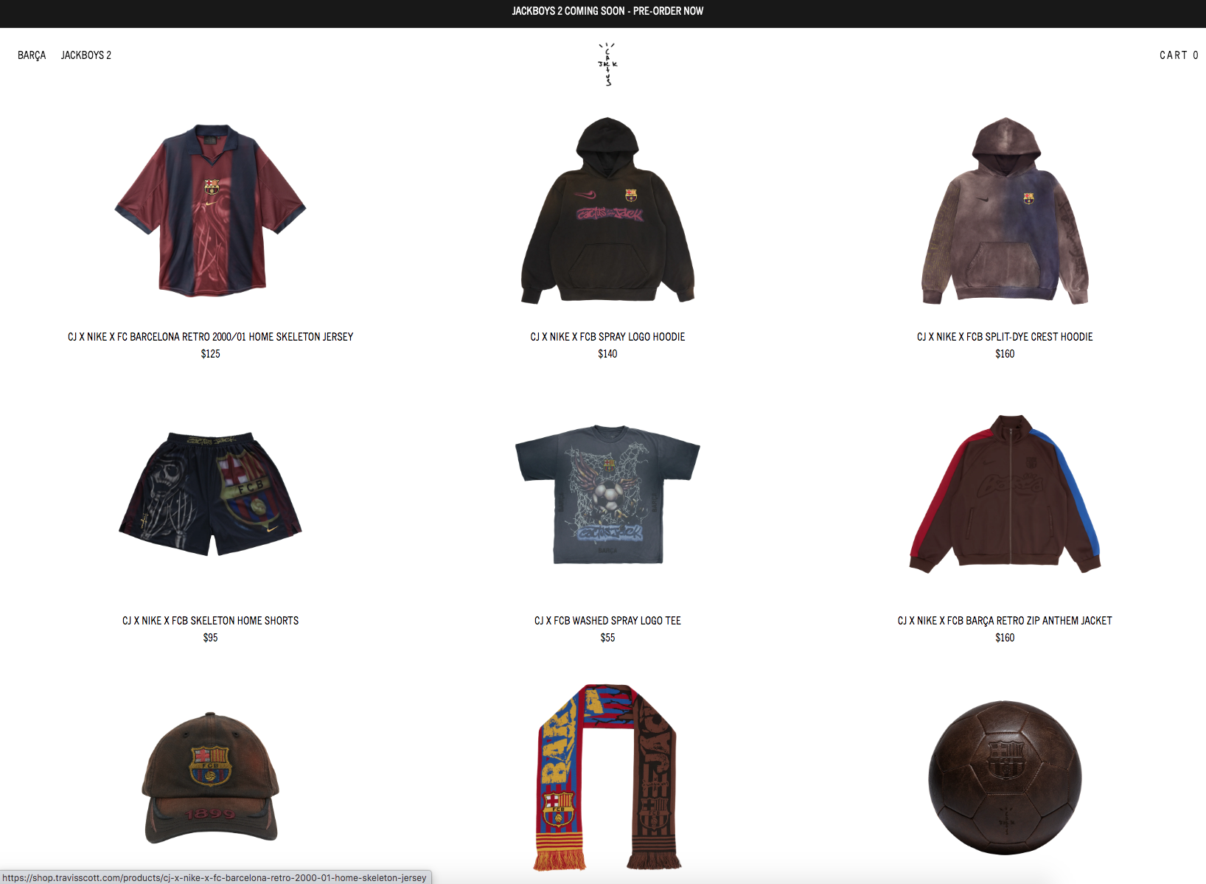

**MUSIC TAB**

**EXAMPLE:**

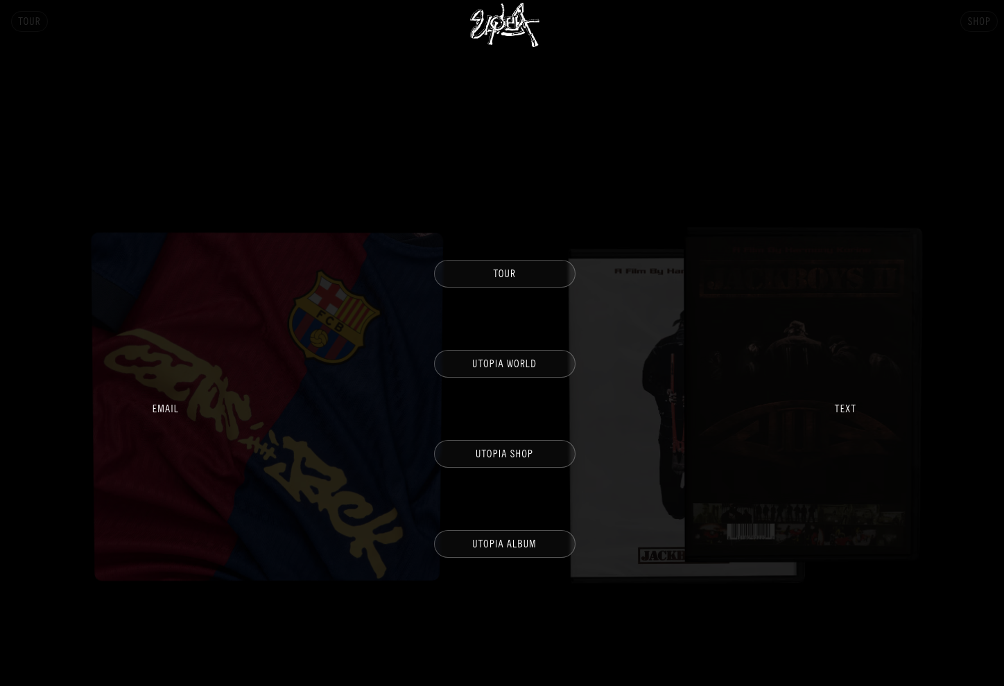

* **“CULT LEADER” TAB (WHEN CLICKED IT TAKES YOU TO PAGE WITH LINKS TO ALL DSPS)**

**-**[**SPOTIFY PLACEMENT PHOTO**](https://drive.google.com/file/d/1oHcmFJx30DWotwUQtW15NrxeS7Ccf1EX/view?usp=drive_link) **(**[**ACTUAL LINK**](https://open.spotify.com/artist/6S4PaG0wJvZOUPxbnrvN4O)**)**

**-**[**ITUNES PLACEMENT PHOTO**](https://drive.google.com/file/d/19RA9iZ-CI40Fj2fFdctEgQjcLSRzVYTe/view?usp=drive_link) **(**[**ACTUAL LINK**](https://music.apple.com/us/artist/billyracxx/1080247220)**)**

**-**[**YOUTUBE PLACEMENT PHOTO**](https://drive.google.com/file/d/1jFE8ymRIxhxy4alXmnoiZfPQjfnd2VAO/view?usp=drive_link) **(**[**ACTUAL LINK**](https://www.youtube.com/c/Billyracxx)**)**

* **“ALIEN IN MY CITY ALBUM” TAB (WHEN YOU CLICK THIS TAB, IT WILL LEAD YOU TO A PAGE THAT CONTAINS** [**ALBUM FRONT COVER**](https://drive.google.com/file/d/1Lyt4gxopQMdTRP39WBow_kGBEyPLQb3m/view?usp=drive_link)**,** [**ALBUM BACK COVER**](https://drive.google.com/file/d/16FZvFiLjo5C_fXYV85Hz9FBbhP0Btm_Y/view?usp=drive_link) **ALONG WITH** [**MADDOG COVER**](https://drive.google.com/file/d/1750QE1QeHV5BdYG0dRWLqUxz_xc9pkKZ/view?usp=drive_link)**,** [**RATHER BE ALIVE COVER**](https://drive.google.com/file/d/1GpsVlthmAIsWPGeqE7pMkW7P_K2J5aXg/view?usp=drive_link)**,** [**UPTIGHT COVER**](https://drive.google.com/file/d/1ZU4n_HIQme1NPxlVvFeGNTv8S1CdK81h/view?usp=drive_link) **&** [**SLUT TALK COVER**](https://drive.google.com/file/d/1w4RCYoCRZY2LzB5Q12ZxxUt30DWhR0Bs/view?usp=drive_link)**, W/ TABS UNDER EACH COVER TO PURCHASE THE VYNIL) (all off this will be blurred out)**

**EXAMPLES:** [**https://www.travisscott.com/explore/**](https://www.travisscott.com/explore/)

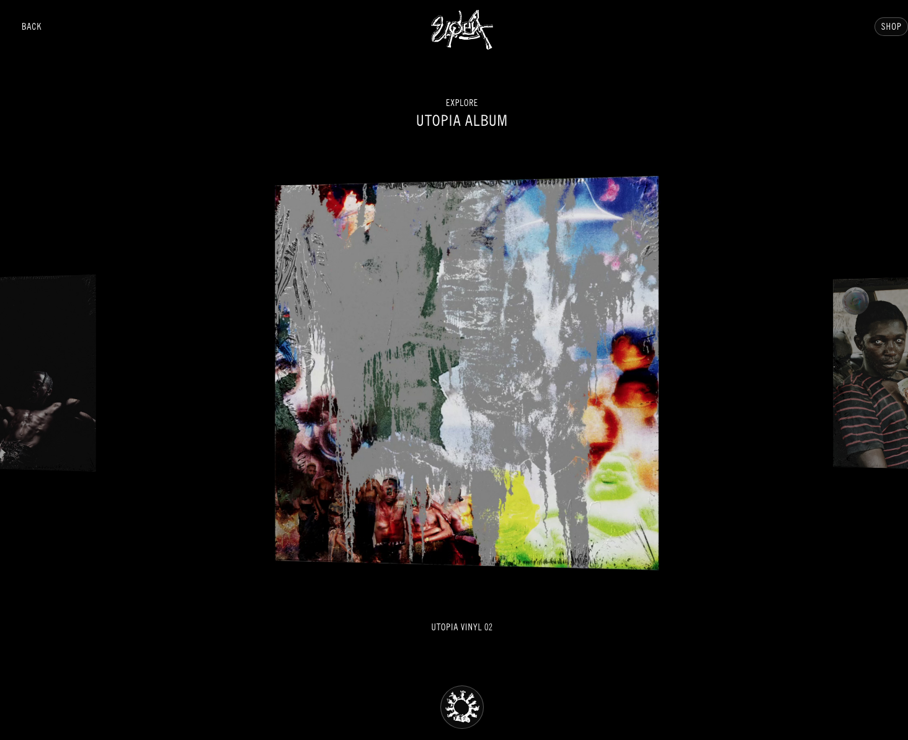

**WHEN YOU CLICK ON THE ALBUM/VINYL THAT YOU WANT, IT TAKES YOU INTO ANOTHER PAGE THAT PROVIDES EMBEDDED LINKS TO STREAM AND OR PURCHASE.**

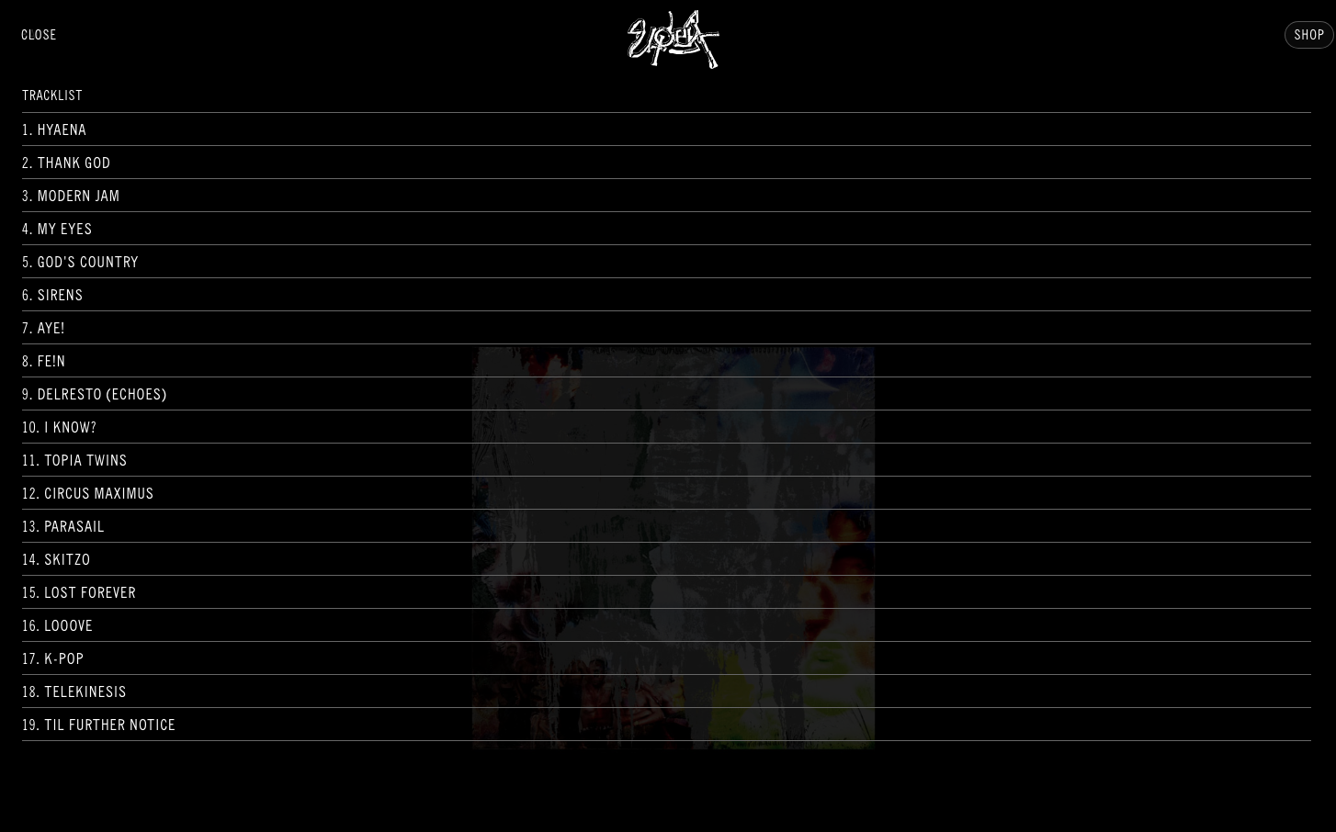

**(TRACK LIST W/ CLICKABLE LINK TO DSP)**

* **“AIMC MUSIC VIDEOS” TAB (THIS PAGE WILL HAVE A CAROUSEL OF EACH VIDEO RELEASED FROM THE PROJECT. WHEN YOU CLICK A VIDEO, IT WILL TAKE YOU TO ANOTHER PAGE WITH THE EMBEDDED YOUTUBE LINK SO THAT YOU CAN WATCH THE VIDEO FROM THE SITE OR NAVIGATE TO YOUTUBE.)**

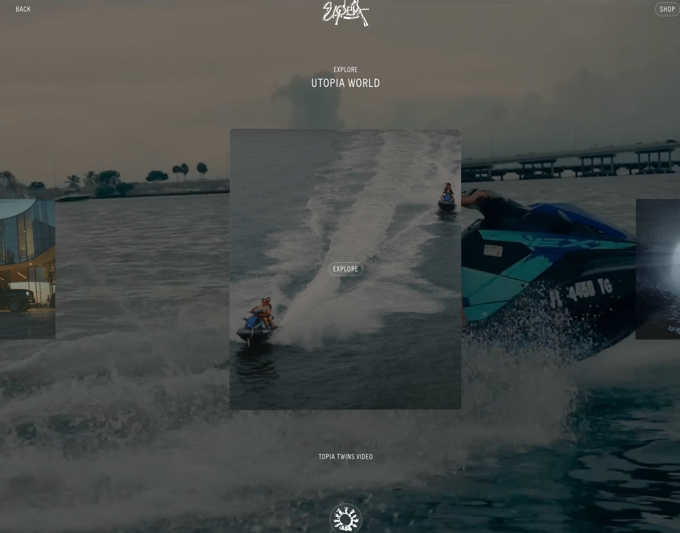

[**https://www.travisscott.com/utopia-world/**](https://www.travisscott.com/utopia-world/)

**LASTLY WE NEED EMAIL & TEXT SUBSCRIPTION TABS AT BOTTOM LEFT CORNER OF HOME PAGE.**

